**Date :** 10/10/2022

**Roll No. and Name :** 22BCE538 Shah Kaivan

**Course Code and Name :** 2CS302 Object Oriented Programming

**Practical No.: 2 (a)**

**AIM:** Write a Java Program that check whether user entered number is special number or not.

**Methodology followed:**

**Input:**

public class p2a

{

public static void main(String args[]) {

int n=59;

int f1=n/10;

int l=n%10;

int sum=f1+l;

int mul=f1*l;

int ans=sum+mul;

System.out.println(ans);

if(ans==n)

{

System.out.println("It is a special number");

}

else

{

System.out.println("It is not a special number");

}

}

}

**Output:**

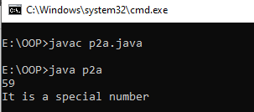

**Conclusion :**

I learnt that how can we separate each digit of number and check whether it is Special number or not?.

**Practical No.: 2 (b)**

**AIM:** Write a Java program using class that prints the numbers 1 to N (N must be scan from the user). For all multiples of 3 print “Bizz” and for all multiples of 5 print “Fizz”. For multiples of both 3 and 5 print “BizzFizz”.

**Methodology followed:**

**Input:**

import java.util.Scanner;

class Bizz

{

public static void main(String args[])

{

Scanner sc = new Scanner(System.in);

int n;

System.out.print("Enter Value: ");

n=sc.nextInt();

for(int i=1;i<=n;i++)

{

//System.out.println(i);

if(i%3==0 && i%5==0)

{

System.out.println(i+"-BizzFizz");

}

else if(i%3==0)

{

System.out.println(i+"-Bizz");

}

else if(i%5==0)

{

System.out.println(i+"-Fizz");

}

else

{

System.out.println(i);

}

}

}

}

**Output:**

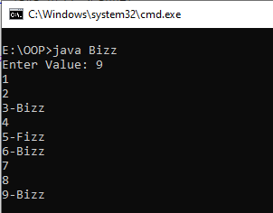

**Conclusion :**

I learnt how to use for loops and modulo operations with the conditional statement and get desirable results.

**Practical No.: 2 (c)**

**AIM:** Write a Java program that demonstrate the concepts of automatic and explicit type casting.

**Methodology followed:**

**Input:**

public class p2c

{

public static void main (String args[])

{

int i = 99;

float f = 99.18f;

double d = 18.99d;

long l = 999999;

float if1 = i;

float lf = l;

double id = i;

double fd = f;

double ld = l;

// Integer and Long to Float

System.out.println ("Integer: " + if1);

System.out.println ("Integer: " + lf);

// Integer, Float and Long to Double

System.out.println ("Double: " + id);

System.out.println ("Double: " + fd);

System.out.println ("Double: " + ld);

// Integer to Float, Double and Long

System.out.println ("Float: " + (float) i);

System.out.println ("Double: " + (double) i);

System.out.println ("Long: " + (long) i);

// Float to Int, Double and Long

System.out.println("Integer: "+(int)f);

System.out.println("Double: "+(double)f);

System.out.println("Long: "+(long)f);

// Double to Integer, Float and Long

System.out.println("Integer: "+(int)d);

System.out.println("Float: "+(float)d);

System.out.println("Long: "+(long)d);

// Long to Integer, Float and Double

System.out.println("Integer: "+(int)l);

System.out.println("Float: "+(float)l);

System.out.println("Double: "+(double)l);

}

}

**Output:**

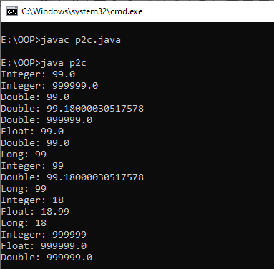

**Conclusion:**

I learnt about how we have study the difference between each data types And importance.

**Practical No.: 2 (d).i**

**AIM:** Write a Java program to: check whether a number is odd or even (using if – else statement)

**Methodology followed:**

**Input:**

import java.util.*;

class odd

{

public static void main(String args[])

{

int n;

System.out.print("Enter Value: ");

Scanner s = new Scanner(System.in);

n=s.nextInt();

//Condition to check odd or even

if(n%2==0)

{

System.out.println(n+" is Even");

}

else

{

System.out.println(n+" is Odd");

}

}

}

**Output:**

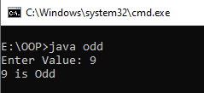

**Conclusion :**

I learnt how to check whether the number is odd or even.

**Practical No.: 2 (d).ii**

**AIM:** Write a Java program to: check the category of a given character. (using if…else…if ladder)

**Methodology followed:**

**Input:**

import java.util.*;

class Cate

{

public static void main(String args[])

{

Scanner scan = new Scanner(System.in);

System.out.print("Enter String: ");

char c = scan.next().charAt(0);

int a=c;

if(a>=65 && a<=90)

{

System.out.println("Uppercase");

}

else if(a>=97 && a<=122)

{

System.out.println("Lowercase");

}

else if(a>=48 && a<=57)

{

System.out.println("Digit");

}

else if(a>=33 && a<=47 || a>=58 && a<=64 || a>=91 && a<=96 || a>=123 && a<=126)

{

System.out.println("Special Character");

}

}

}

**Output:**

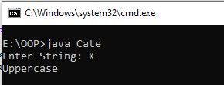

**Conclusion :**

I learnt how to check the category of Character whether it is lowercase, uppercase, digit or a special character.

**Practical No.: 2 (d).iii**

**AIM:** Write a Java program to: check whether a number is prime or not. (using for loop)

**Methodology followed:**

**Input:**

import java.util.*;

class Prime

{

public static void main(String args[])

{

int n,flag=1;

Scanner scan = new Scanner(System.in);

n=scan.nextInt();

for(int i=2;i<n;i++)

{

if(n%i==0)

{

flag=0;

break;

}

}

if(flag==1)

{

System.out.println(n+" is Prime Number");

}

else

{

System.out.println(n+"is Not Prime Number");

}

}

}

**Output:**

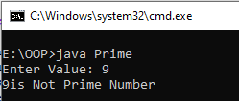

**Conclusion :**

I learnt how to check whether the number is prime number or not prime.

**Practical No.: 2 (d).iv**

**AIM:** Write a Java program to: display reverse of a number and check whether it is palindrome or not. (using while/do while loop)

**Methodology followed:**

**Input:**

import java.util.*;

class pal

{

public static void main(String args[]) {

int n,rev=0,mod;

Scanner scan = new Scanner(System.in);

System.out.print("Enter Value: ");

n = scan.nextInt();

int temp=n;

while(n>0)

{

mod = n%10;

rev = (rev*10) + mod;

n = n/10;

}

if(temp==rev)

{

System.out.println("It is Palindrome");

}

else

{

System.out.println("It is not a Palindrome");

}

}

}

**Output:**

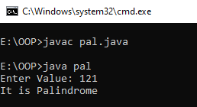

**Conclusion :**

I learnt how to reverse the number and check whether the number is palindrome or not.

**Practical No.: 2 (d).v**

**AIM:** Write a Java program to: pattern printing. (using nested loops)

1

1 2

1 2 3

1 2 3 4

1 2 3 4 5

1 2 3 4 5 6

**Methodology followed:**

**Input:**

class pattern

{

public static void main(String args[])

{

int i,j,k;

for(i=1;i<=7;i++)

{

for(j=6;j>=i;j--)

{

System.out.print(" ");

}

for(k=1;k<i;k++)

{

System.out.print(k);

}

System.out.println();

}

}

}

**Output:**

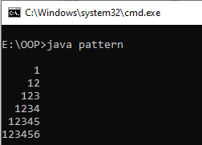

**Conclusion :**

I learnt how to print a pattern using nested for loops.